Written Assignment Content

Top of Form

Chapter-10:

R-10.4 What is the worst-case running time for inserting n key-value pairs into an initially empty map M that is implemented with the UnsortedTableMap class?

* **O(N) is the worst case running time.**

R-10.9 Draw the 11-entry hash table that results from using the hash function, h(i)=(3i+5) mod 11, to hash the keys 12, 44, 13, 88, 23, 94, 11, 39, 20, 16, and 5, assuming collisions are handled by chaining.

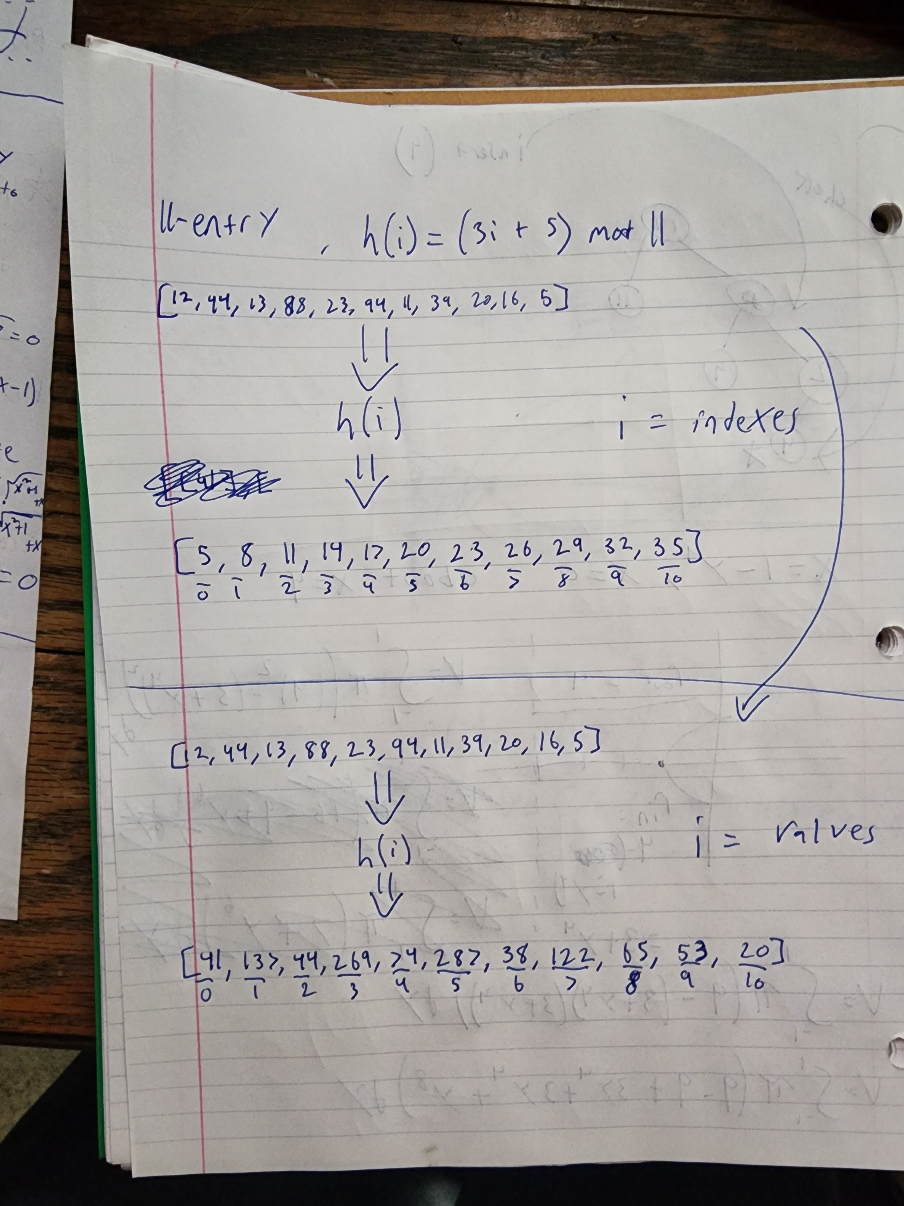

C-10.42 Suppose that each row of an n×n array A consists of 1’s and 0’s such that, in any row of A, all the 1’s come before any 0’s in that row. Assuming A is already in memory, describe a method running in O(nlogn) time (not O(n2) time!) for counting the number of 1’s in A.

* **Iterating down every row in A. Since all of the 1’s come first in the beginning indexes of each row, the second a 0 is discovered just break from that row and move to the next row. This is essentially a 2D array that has every row containing 1’s first and then 0’s to n size.**

Chapter-11:

R-11.2 Insert, into an empty binary search tree, entries with keys 30, 40, 24, 58, 48, 26, 11, 13 (in this order). Draw the tree after each insertion

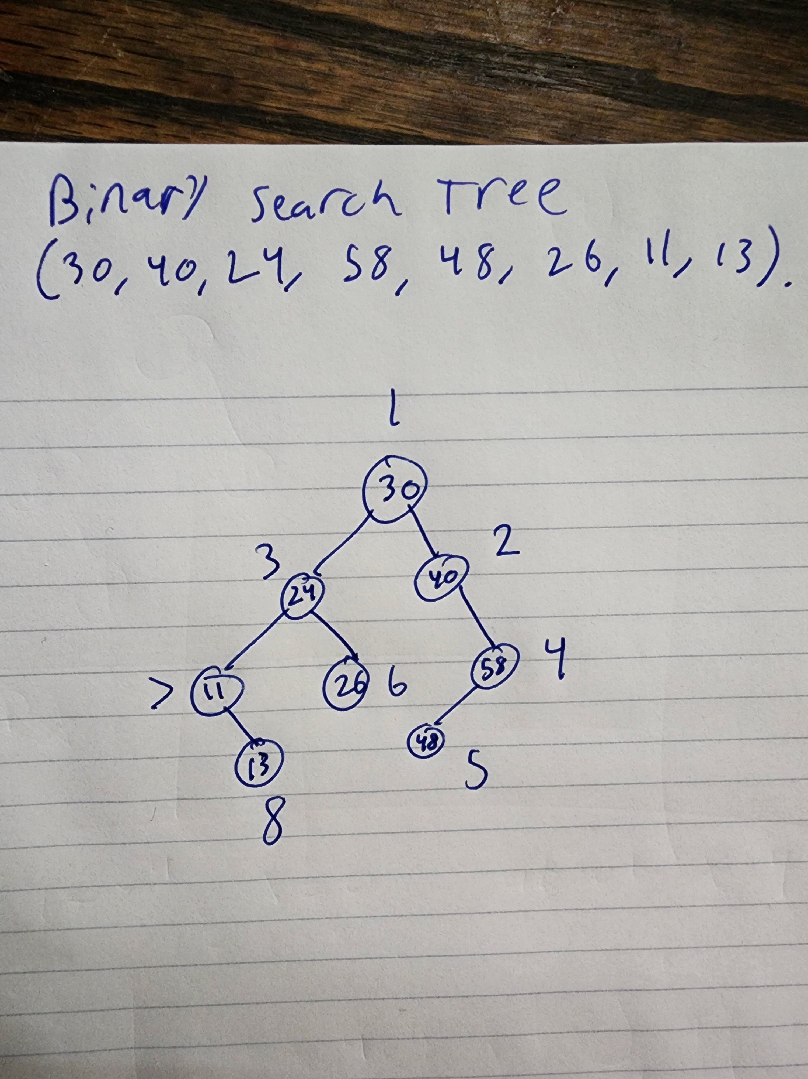

R-11.5 Dr. Amongus claims that the order in which a fixed set of entries is inserted into an AVL tree does not matter—the same AVL tree results every time. Give a small example that proves he is wrong.

**So say the insertion keys are (1,2,3,4,5,6,7,8,9). In normal insertions this would insert every new key to the right child of the previously placed key in the tree. The tree would have no left children that exists which would result in a very unbalanced tree.**

R-11.8 Draw the AVL tree resulting from the insertion of an entry with key 52 into the AVL tree of Figure 11.14b.

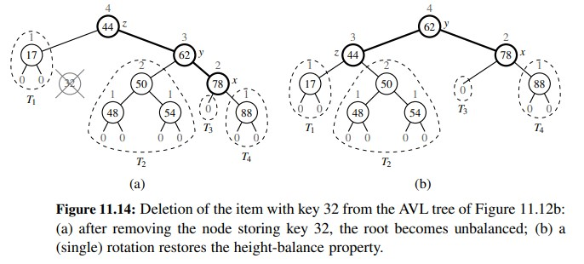

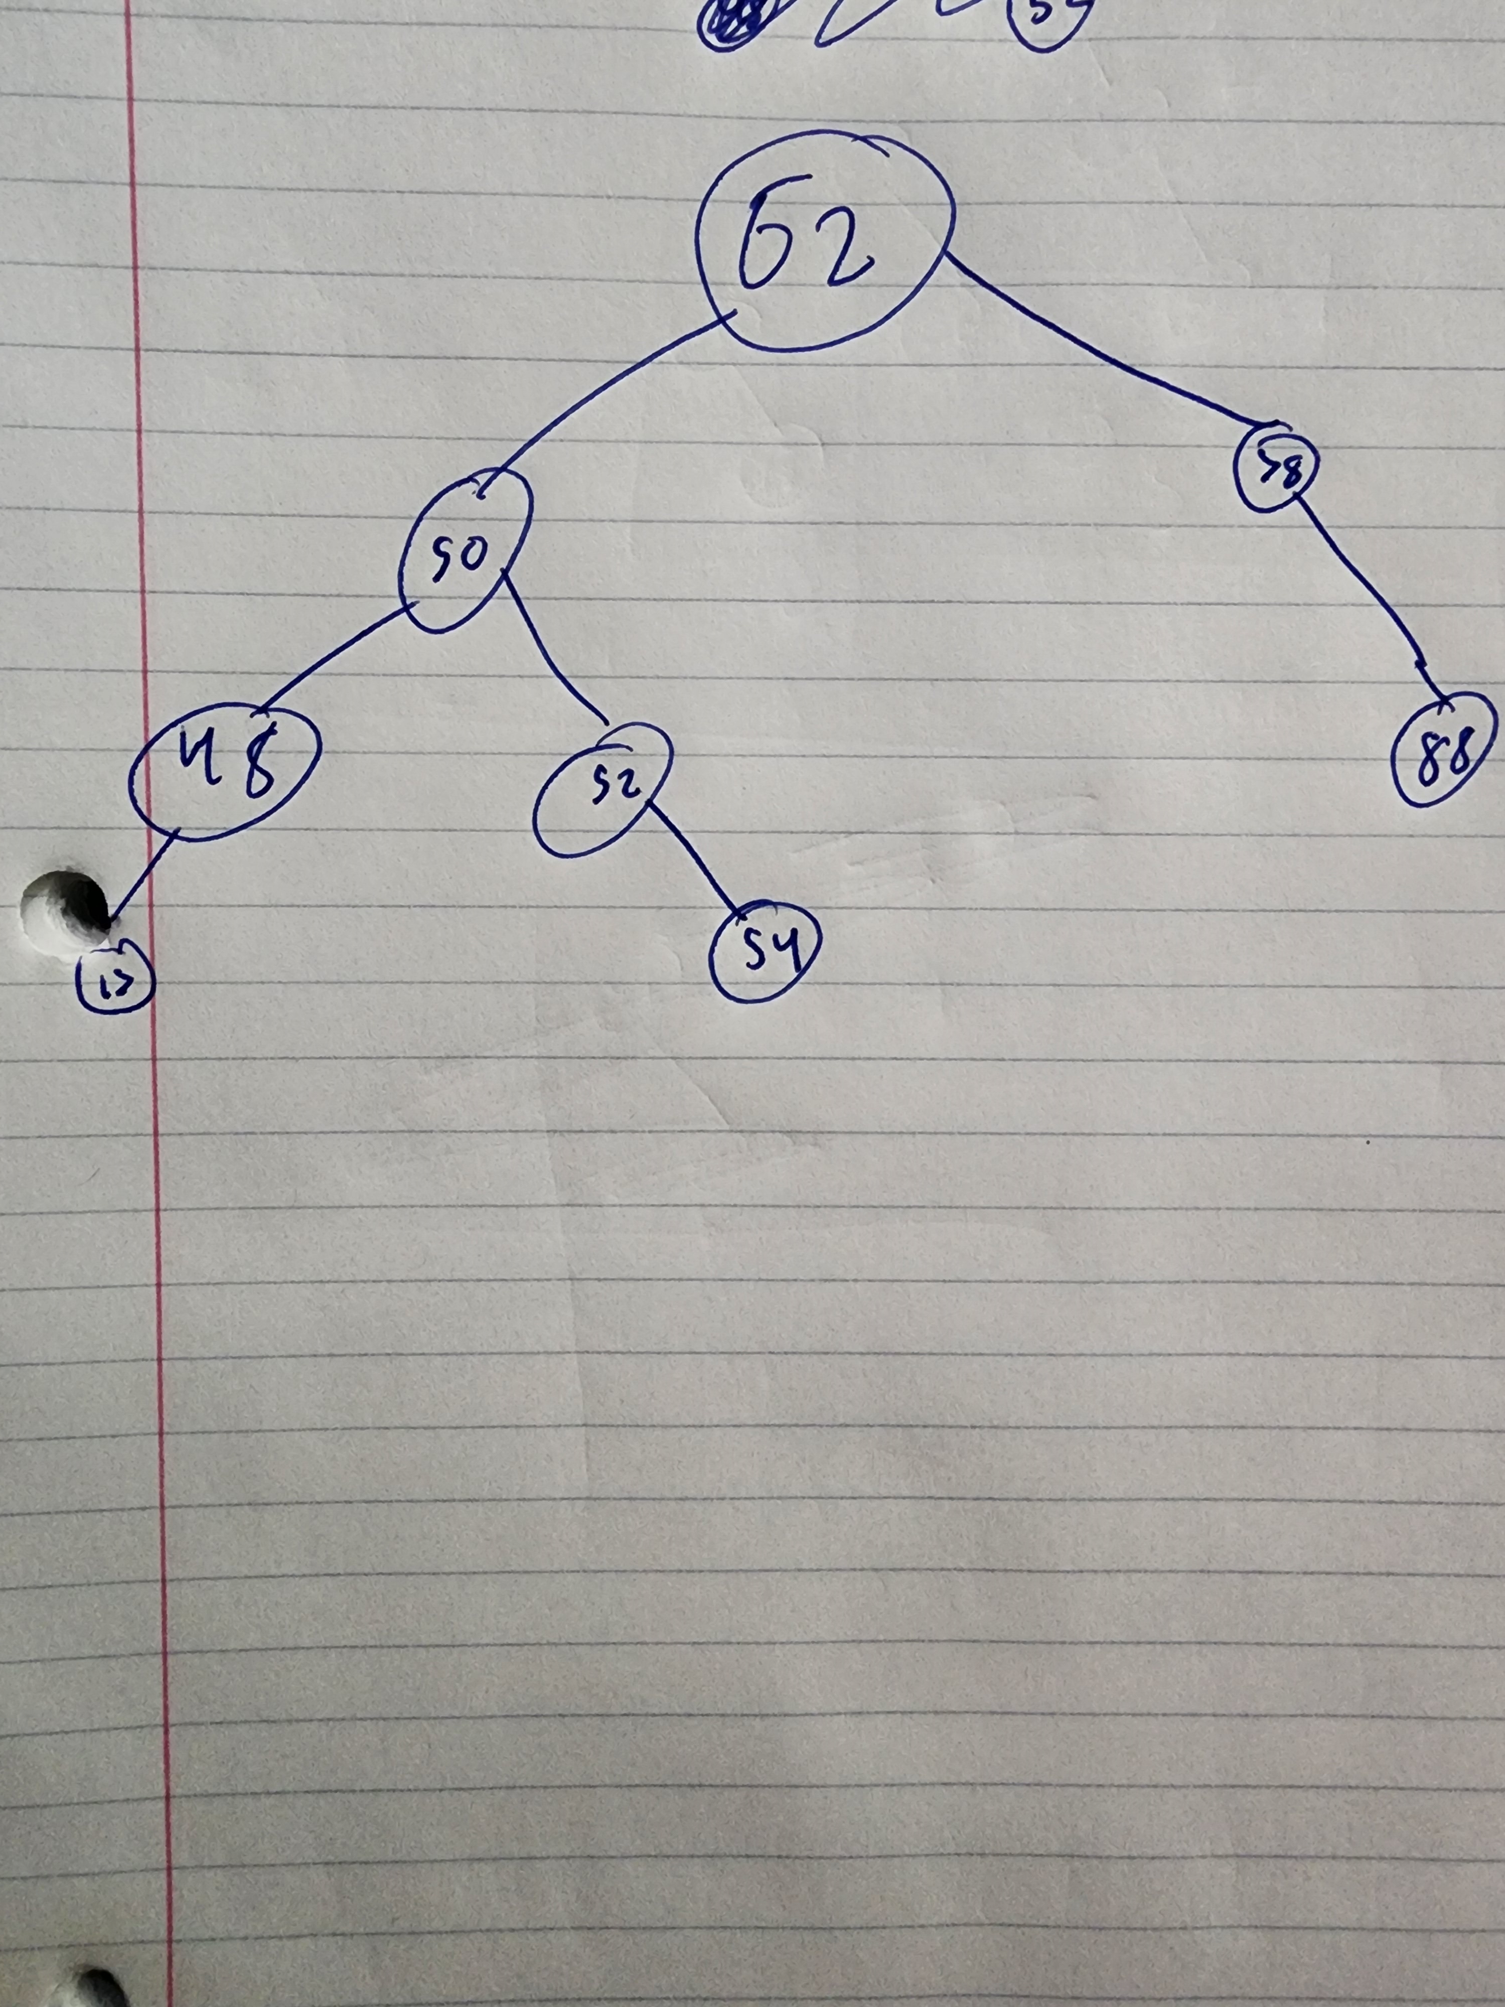

C-11.29 Explain how to use an AVL tree or a red-black tree to sort n comparable elements in O(nlogn) time in the worst case.

**Obtaining a list of values to insert into an AVL tree. By the tree being an AVL tree and being both a BST and balanced will resort in the values being sorted by traversing the tree in an in_order traversal. That’s a simple way to sort a list of elements in O(log)n time.**